**[S300/G500] CMU Recovery Guide**

**2016.02.24**

1. **CMU Recovery pkg**

**Recovery pkg must use ipx-sysn-x.x.x.x.img format file.**

**Unzip ipx-sys_x.x.x.x.tgz and use ipx-sysn-x.x.x.x.img**

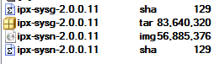

1. **INSTALL and SETUP TFTP Server** 
   1. Setup upgrade environment
      1. Create the folder within your PC

ex) "C:\ SMB\Boot\"

* + 1. Copy Image files into the directory and unzip it.
    2. Connect SIO cable between PC & CMU Board console port(if Y cable, Port 1).
    3. Connect LAN cable between PC & S300 or G500 GbE Port 1
    4. Either a straight or a cross LAN cable would be OK
  1. Setup TFTP Server

The recommended program of TFTP is "**Tftpd32**" (free utility program)

* + 1. Execute "tftpd32.exe" (No required installation)

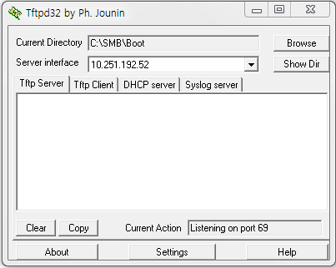

* + 1. **Click the "[Settings]" button and set "Base directory " to “C:\SMB\Boot” folder**

All software packages should be located into "Base directory" after unzipping.

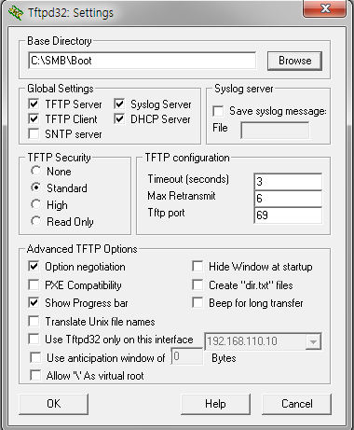

1. **CMU Image Recovery** 
   1. **Setup up system and SIO Cable**
      1. Setup Configuration



- LAN Cable connect to GbE Port 1

- Console Cable Connect to Console Port in the S300/G500 Board Side

(If Y cable, connect port1)

* 1. **Make boot mode and set config**
     1. Make a boot mode

**System power on** , **hit the "Ctrl+c" key after 3 seconds**, **then you can enter the boot mode**.

If you want to check current ipaddr status, type ‘printenv’ command.

2.2.2 **Assign ipaddr & gatewayip for CMU board** and then assign serverip for tftp server

(your computer IP)

2.2.3 Assign pkgfile for update image name

2.2.4 Save there changes (**saveenv**) and then Enter **reset** command for upgrade.

1) setenv ipaddr 10.0.2.10

2) setenv gatewayip 10.0.2.1

3) setenv serverip 10.0.2.100

**4) setenv pkgfile ipx-sysn-2.0.0.15.img <- according to your image version, change the name**

5) saveenv

6) reset

You can see these steps from the below image

IPTGW-NPU UBOOT (Nov 15 2014 - 11:18:47)

I2C: ready

DEV ID = 0xcf1e

PCIE CFG DEV ID = 0x8022

OTP offset(0x8): 0x78701c01

OTP offset(0x9): 0xfe080018

OTP offset(0xa): 0xc01b0

OTP offset(0xb): 0x0

OTP offset(0xc): 0x4400000

OTP offset(0xd): 0xbcdde030

OTP offset(0xe): 0x35b17f

OTP offset(0xf): 0x3c

SKU ID = 0x0

….

relocation Offset is: 9fef4000

relocate_code: sp = 1001f38, id = 1003f48, addr = f24000

WARNING: Caches not enabled

monitor flash len: 000DA0B4

set sdio pin and gpio ...

Now running in RAM - U-Boot at: 00f24000

NAND: cs 0 dev_id word 0 1d3d195

Spansion S34ML08G1,

Strap options for this NAND: page=1 type=1

Overriding invalid strap options: strap_type=2

128 KiB blocks, 2 KiB pages, 16B OOB, 8-bit

NAND: chipsize 1024 MiB

MMC: iproc_mmc: 0

soc_pcie_hw_init : port->reg_base = 0x18012000 , its value = 0x1

PCIe port in RC mode

==>PCIE: LINKSTA reg 0xbe val 0x1001

**************

port 0 is not active!!

**************

In: serial

Out: serial

Err: serial

arm_clk=1000MHz, axi_clk=500MHz, apb_clk=250MHz, arm_periph_clk=500MHz

Enabling icache and dcache

Enabling l2cache

Net: Registering eth

Broadcom BCM IPROC Ethernet driver 0.1

Using GMAC1 (0x18023000)

et0: ethHw_chipAttach: Chip ID: 0xcf1e; phyaddr: 0x1e

ethHw_chipAttach READ P5_MUX_CONFIG: 0x3d2,reg 0x1803f308

ethHw_chipAttach WRITE P5_MUX_CONFIG: 0x3d2 at reg 0x1803f308

bcm_robo_attach: devid: 0x53025

bcmiproc_eth-0

I2C read: address out of range

Reboot cause: Unknown

Hit ctrl+C key to stop autoboot: 0

**IPTGW-NPU> <INTERRUPT>Hit any key to stop autoboot: 0 <- Ctrl+c**

**IPTGW-NPU> setenv ipaddr 10.0.2.22 <- CMU Board IP Address**

**IPTGW-NPU> setenv gatewayip 10.0.2.1**

**IPTGW-NPU> setenv serverip 10.0.2.100 <- PC TFTP Server IP Address**

**IPTGW-NPU> setenv pkgfile ipx-sysn-2.0.0.15.img**

**IPTGW-NPU> saveenv**

**IPTGW-NPU> reset**

**2.3 Do recovery with image file**

**0. Enter the boot status by ctrl+c.**

**1. Do nand erase**

IPTGW-NPU> **nand erase.part UBI**

NAND erase.part: device 0 offset 0xe00000, size 0x3f200000

Skipping bad block at 0x28340000

Erasing at 0x3ffe0000 -- 100% complete.

OK

IPTGW-NPU>

**2. Do create partition**

IPTGW-NPU> **run mkubivol**

Creating 1 MTD partitions on "nand0":

0x000000e00000-0x000040000000 : "mtd=4"

UBI: attaching mtd1 to ubi0

UBI: physical eraseblock size: 131072 bytes (128 KiB)

UBI: logical eraseblock size: 126976 bytes

UBI: smallest flash I/O unit: 2048

UBI: VID header offset: 2048 (aligned 2048)

UBI: data offset: 4096

UBI: empty MTD device detected

UBI: create volume table (copy #1)

UBI: create volume table (copy #2)

UBI: attached mtd1 to ubi0

UBI: MTD device name: "mtd=4"

UBI: MTD device size: 1010 MiB

UBI: number of good PEBs: 8079

UBI: number of bad PEBs: 1

UBI: max. allowed volumes: 128

UBI: wear-leveling threshold: 4096

UBI: number of internal volumes: 1

UBI: number of user volumes: 0

UBI: available PEBs: 7995

UBI: total number of reserved PEBs: 84

UBI: number of PEBs reserved for bad PEB handling: 80

UBI: max/mean erase counter: 1/0

Creating dynamic volume rootfs0 of size 104857600

Creating dynamic volume rootfs1 of size 104857600

Creating dynamic volume configs of size 293601280

Creating dynamic volume log of size 503316480

Continue..

**3. Do image upgrade and booting**

IPTGW-NPU> **run updatepkg**

UBI: mtd1 is detached from ubi0

Creating 1 MTD partitions on "nand0":

0x000000e00000-0x000040000000 : "mtd=4"

UBI: attaching mtd1 to ubi0

UBI: physical eraseblock size: 131072 bytes (128 KiB)

UBI: logical eraseblock size: 126976 bytes

UBI: smallest flash I/O unit: 2048

UBI: VID header offset: 2048 (aligned 2048)

UBI: data offset: 4096

UBI: attached mtd1 to ubi0

UBI: MTD device name: "mtd=4"

UBI: MTD device size: 1010 MiB

UBI: number of good PEBs: 8079

UBI: number of bad PEBs: 1

UBI: max. allowed volumes: 128

UBI: wear-leveling threshold: 4096

UBI: number of internal volumes: 1

UBI: number of user volumes: 4

UBI: available PEBs: 66

UBI: total number of reserved PEBs: 8013

UBI: number of PEBs reserved for bad PEB handling: 80

UBI: max/mean erase counter: 5/1

Using bcmiproc_eth-0 device

TFTP from server 10.251.192.230; our IP address is 10.251.194.53; sending through gateway 10.251.194.1

Filename 'iptgw-npu.img'.

Load address: 0x68000000

Loading:

######################################################

done

Bytes transferred = 34537600 (20f0080 hex)

==================================================

MODEL : ipx-g500

FAMILY : iptgw-npu

VERSION : V1.0.0.1

DATE : Wed Jul 29 08:51:10 KST 2015

CRC : 0xa4ab1574

SIZE : 0x20f0000 (34537472)

==================================================

34537472 bytes written to volume rootfs1

Erasing redundant NAND...360000

Erasing at 0x3a0000 -- 100% complete.

Writing to redundant NAND... Erasing NAND...300000

Erasing at 0x340000 -- 100% complete.

Writing to NAND... done **<= done means correct recovery**

**IPTGW-NPU> reset**

**2.4 If error, check this**

Here is error cause of mismatch family name. Set family name and do run updatepkg

…

#################################################################

#################################################################

##########################################################

done

Bytes transferred = 57139328 (367e080 hex)

==================================================

MODEL : IPX-SYSN

FAMILY : IPX-SYSN

VERSION : V2.0.0.12

DATE : Fri Oct 14 21:24:02 KST 2016

CRC : 0x9105d353

SIZE : 0x367e000 (57139200)

==================================================

**mismatch model (<NULL>) or <= error**

**family (ipx-g500) !!**

Using bcmiproc_eth-0 device

**IPTGW-NPU> setenv family IPX-SYSN <= change family name**

**IPTGW-NPU> saveenv**

**IPTGW-NPU> reset**

**IPTGW-NPU> run updatepkg <= do cmd again**