Kari’s law -- Direct access to 9-1-1 service and multi-line telephone systems

http://texas911.org/karislaw

http://www.kltv.com/story/32945582/karis-law-takes-effect-in-texas-911-access-to-change-for-businesses

The purpose of this notice is to bring your attention to Kari’s law. On Sept 1, 2016, this law came into effect. It is now law in Texas and It requires that a multi-line phone system must connect with the emergency services if the user simply just dials 9-1-1. It means it must not be required that the user first dial a line access code or number in order to call 911. Eg having to dial 9-911 does not comply with the law.
If you haven’t done so yet, it is a good idea to contact your customers and make sure they are in compliance with the law. Even if you are not in Texas, it is most worthwhile sharing this your customers. It just makes good sense.
If they are OfficeServ customers, give them the assurance that you can configure their system to be fully compliant with Kari’s Law and offer them your services.
If they are not, you have the perfect opportunity to provide them with a Samsung solution.
Provided below is a configuration guide to have Samsung’s LCR functionality route emergency calls when 9-1-1 is detected even without a line selection. If you need help call Tech Support – 508 665 4895.

Use case
Configuring LCR to provide Kari’s Law Compliance
1 | 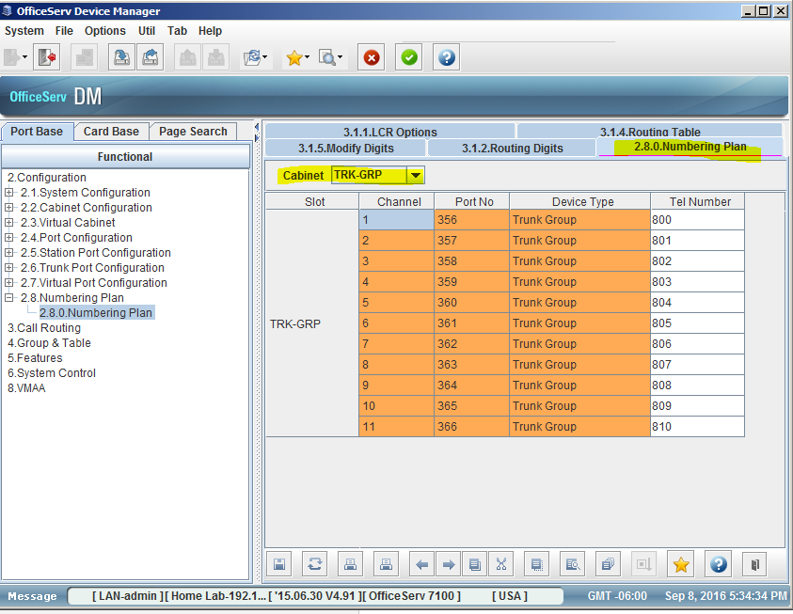 | If you do not already have LCR set up you must delete trunk group 9 and create LCR feature code in MMC 724 / DM 2.8.0 under the TRK-GRP and Features in the drop down menu.  Delete trunk group 9 and start with 800.
2 | 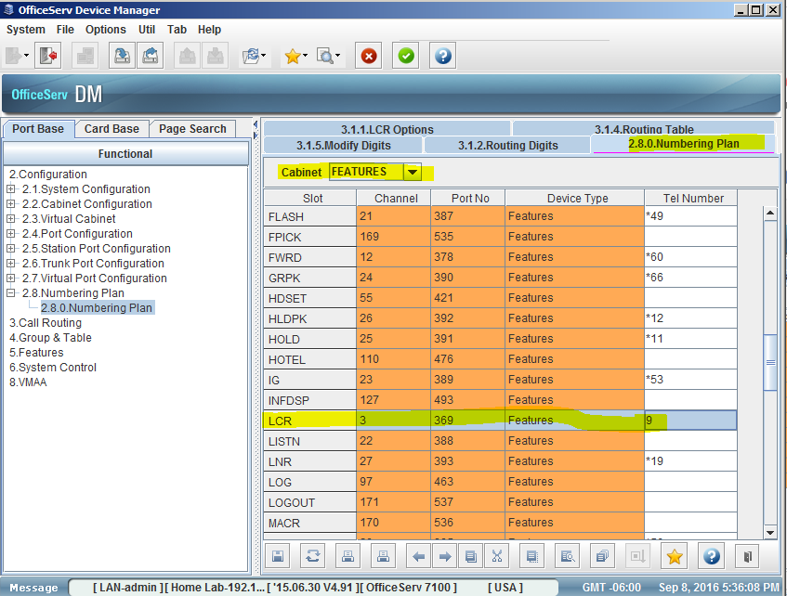 | Create Feature Code 9.
3 | 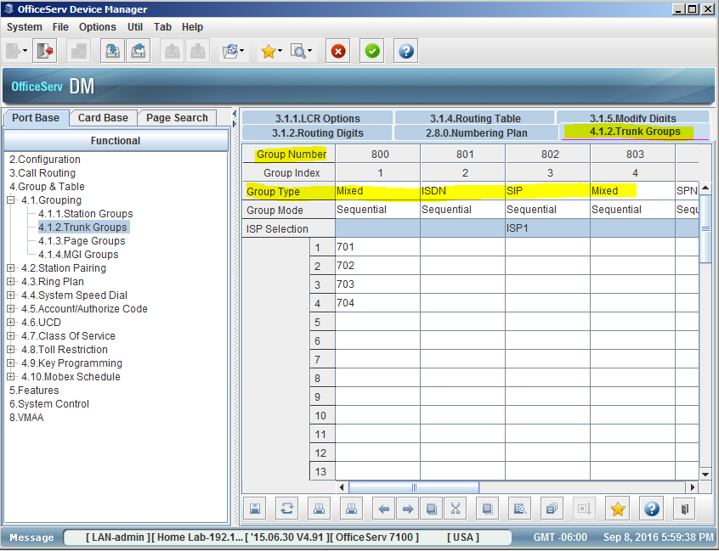 | In MMC 603 / DM 4.1.2 verify your trunks are members of the correct trunk group with the correct trunk type. (ex. Analog, SIP, or ISDN)
4 | 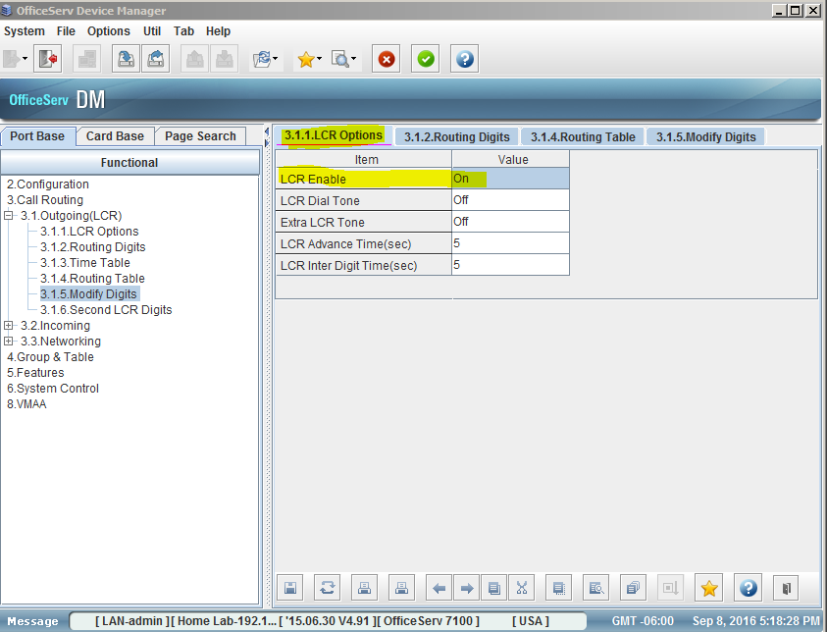 | LCR MMC’s 716, 710, 712, 713 / DM 3.1.1, 3.1.2, 3.1.4, 3.1.5  Turn on LCR in MMC 716 / DM 3.1.1
5 | 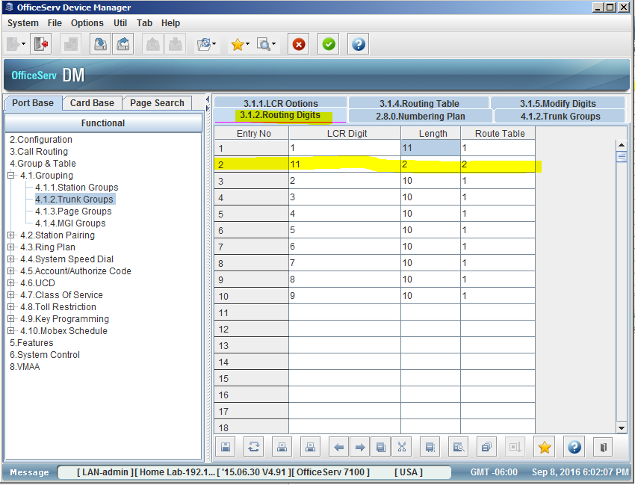 | Create Routing Digits in MMC 710 / DM 3.1.2 if you already have LCR set up then all you have to add is the highlighted field, otherwise create as below.
6 | 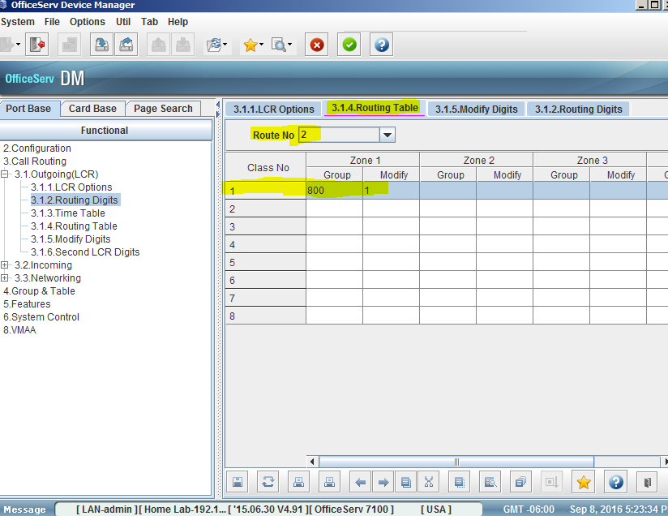 | Create Route Table for your Routing Digits in MMC 712 / 3.1.4, Click the drop down menu for route 2, enter your trunk group with a modifier of 1.
7 | 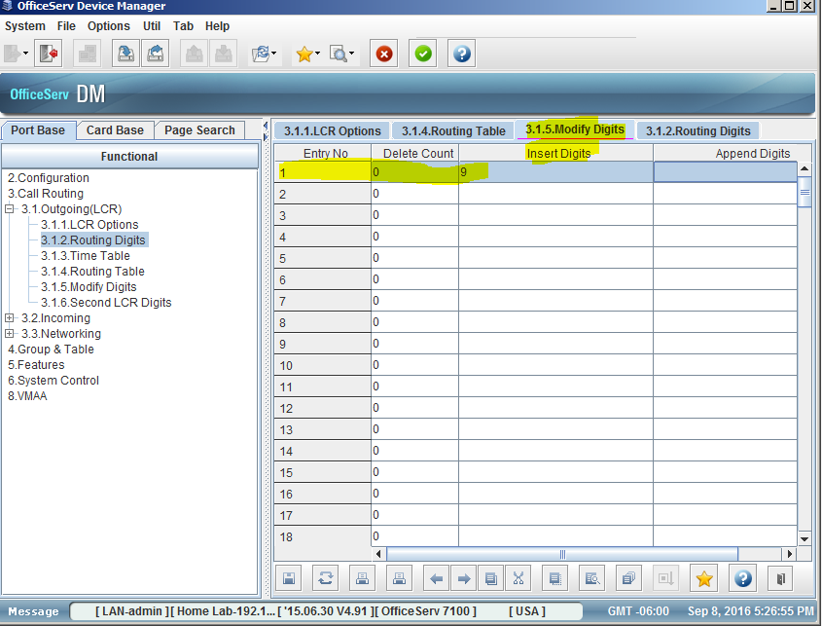 | Last create your modify digits in MMC 713 / DM 3.1.5. under insert digit enter 9.

